Musicfy
Create a Web page (HTML5 + CSS3 + images) that looks and behaves like the screenshot below:
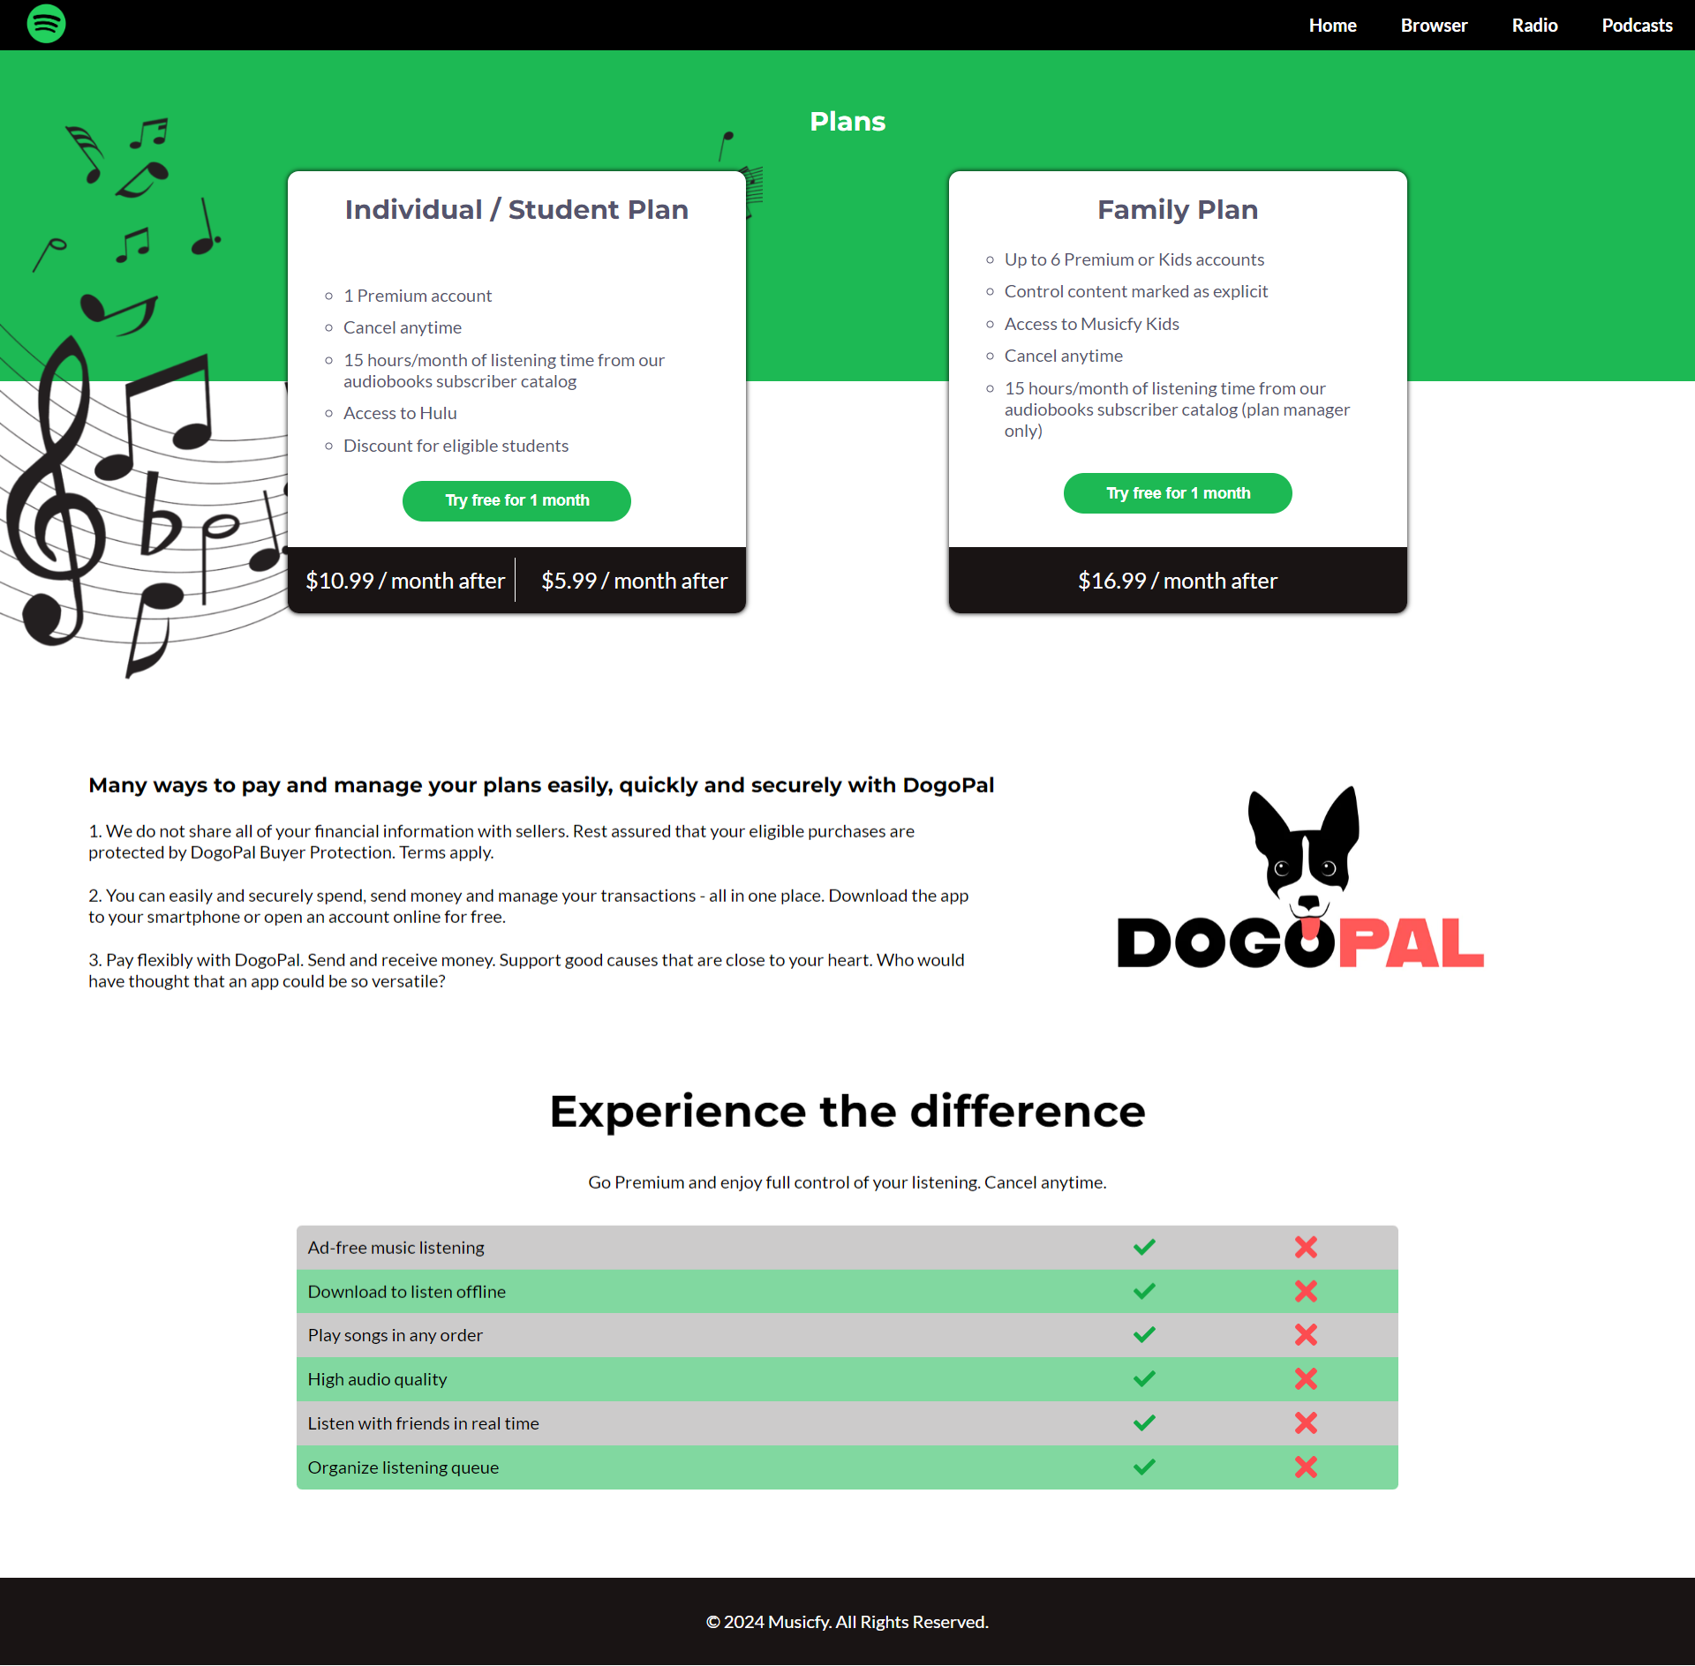
You are given the above screenshots + all required images.

Output
The output should be valid HTML5 + CSS3 + images that implement the above web page.

Constraints
- Use font 'Montserrat' for the headings and font 'Lato' for the text - https://fonts.googleapis.com/css2?family=Lato:ital,wght@0,100;0,300;0,400;0,700;0,900;1,100;1,300;1,400;1,700;1,900&family=Montserrat:ital,wght@0,100;0,200;0,300;0,400;0,500;0,600;0,700;0,800;0,900;1,100;1,200;1,300;1,400;1,500;1,600;1,700;1,800;1,900&display=swap
- The site should open correctly in the latest version of Chrome

